Лабораторна робота № 1
Інтерфейс віконного додатку
Мета: дослідження основних підходів та технологій реалізації інтерфейсу універсалього додатку Windows. Обладнання: ПК, Visual Studio не нижче v.2010 (.Net Framework 4.5).
Хід роботи:

Репозиторій: https://github.com/DmitryKalinovskyi/WPF-TextEditor

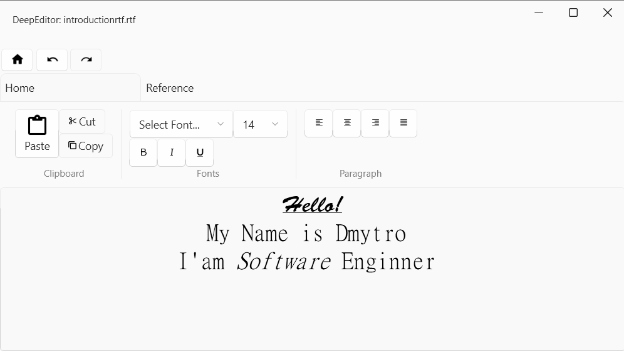
Рис. 1. Вигляд віконного додатку.

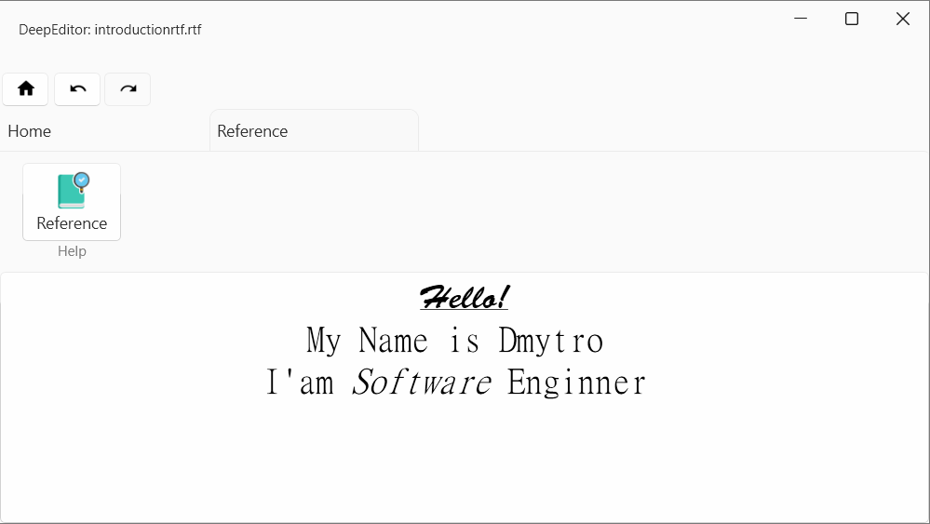
Рис. 2. Вигляд віконного додатку
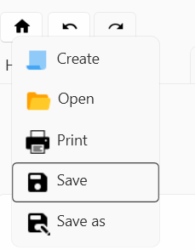
Рис. 3.

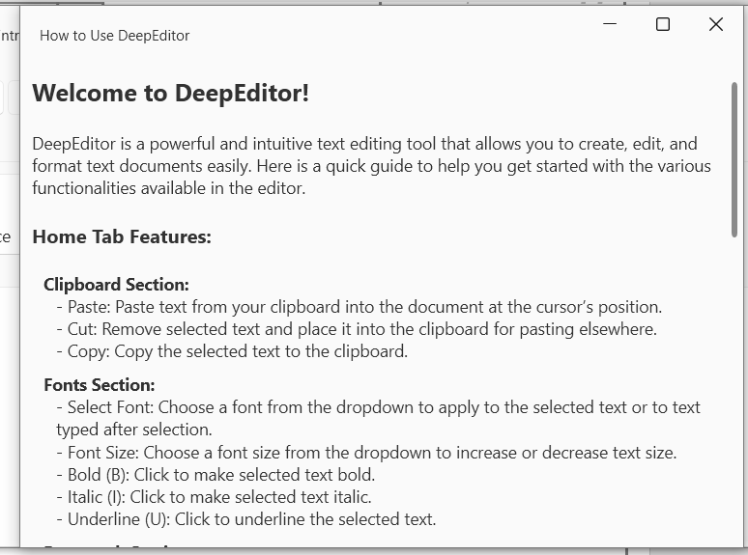
Рис. 4. Вікно справки.

Висновок: на цій практичній роботі я досліджував основні підходи та технології реалізації інтерфейсу універсалього додатку Windows.

Лістинг програми:
MainWindow.xaml
<ui:FluentWindow x:Class="Word.MainWindow"
xmlns="http://schemas.microsoft.com/winfx/2006/xaml/presentation"
xmlns:x="http://schemas.microsoft.com/winfx/2006/xaml"
xmlns:d="http://schemas.microsoft.com/expression/blend/2008"
xmlns:mc="http://schemas.openxmlformats.org/markup-compatibility/2006"
xmlns:local="clr-namespace:Word"
xmlns:ui="http://schemas.lepo.co/wpfui/2022/xaml"
xmlns:vm="clr-namespace:Word.ViewModels"
xmlns:toolkit="http://schemas.xceed.com/wpf/xaml/toolkit"
mc:Ignorable="d"
Height="450" Width="800"

WindowStartupLocation="CenterScreen">
<ui:FluentWindow.Resources>
<vm:MainWindowViewModel x:Key="MainWindowViewModel"/>
</ui:FluentWindow.Resources>
<ui:FluentWindow.DataContext>
<StaticResource ResourceKey="MainWindowViewModel"/>
</ui:FluentWindow.DataContext>
<Grid>
<Grid.RowDefinitions>
<RowDefinition Height="60"/>
<RowDefinition Height="auto"/>
<RowDefinition Height="auto"/>
<RowDefinition Height="*"/>
</Grid.RowDefinitions>
<ui:TitleBar Title="{Binding DocumentViewModel.Title}">
</ui:TitleBar>

<StackPanel Orientation="Horizontal" Grid.Row="1">
<Button Click="Button_Click"
Margin="2, 2"
>
<Button.ContextMenu>
<ContextMenu StaysOpen="true" x:Name="ContextMenu" DataContext="{StaticResource MainWindowViewModel}">
<!--<MenuItem Header="Open" Icon="{StaticResource }"/>-->
<MenuItem Header="Create" Command="{Binding DocumentViewModel.CreateNewCommand}">
<MenuItem.Icon>
<Image Source="{StaticResource PaperIcon24Source}" Width="24"/>
</MenuItem.Icon>
</MenuItem>
<MenuItem Header="Open"
Command="{Binding DocumentViewModel.OpenDocumentCommand}">
<MenuItem.Icon>
<Image Source="{StaticResource OpenedFolderIcon24Source}" Width="25"/>
</MenuItem.Icon>
</MenuItem>
<MenuItem Header="Print" Command="{Binding DocumentViewModel.PrintCommand}">
<MenuItem.Icon>
<Image Source="{StaticResource PrintIcon25Source}" Width="24"/>
</MenuItem.Icon>
</MenuItem>
<MenuItem Header="Save" Command="{Binding DocumentViewModel.SaveCommand}">
<MenuItem.Icon>
<Image Source="{StaticResource SaveIcon24Source}" Width="24"/>
</MenuItem.Icon>
</MenuItem>
<MenuItem Header="Save as"
Command="{Binding DocumentViewModel.SaveAsCommand}">
<MenuItem.Icon>
<Image Source="{StaticResource SaveAsIcon24Source}" Width="24"/>
</MenuItem.Icon>
</MenuItem>
<!--<MenuItem Header="Preferences" Click="MenuPreferences_Click" >
<MenuItem.Icon>
<Image Source="{StaticResource OptionsIcon24Source}" Width="24"/>
</MenuItem.Icon>
</MenuItem>-->
<!--<MenuItem Header="Recent Files">
<MenuItem Header="ReadMe.txt"/>
<MenuItem Header="Schedule.xls"/>
</MenuItem>-->
</ContextMenu>
</Button.ContextMenu>
<Button.Content>
<StackPanel Orientation="Horizontal" >
<Border Width="16">
<StaticResource ResourceKey="HomeIcon24"/>
</Border>
<!--<TextBlock VerticalAlignment="A">Home</TextBlock>-->
</StackPanel>
</Button.Content>
</Button>
<Button Margin="2, 2" Command="{x:Static ApplicationCommands.Undo}"
CommandTarget="{Binding ElementName=DocumentTextBox}">
<Border Width="16">
<StaticResource ResourceKey="UndoIcon24"/>
</Border>
</Button>
<Button Margin="2, 2" Command="{x:Static ApplicationCommands.Redo}"
CommandTarget="{Binding ElementName=DocumentTextBox}">
<Border Width="16">
<StaticResource ResourceKey="RedoIcon24"/>
</Border>
</Button>
</StackPanel>

<TabControl Grid.Row="2">
<TabControl.Resources>
<Style x:Key="ToolButton" TargetType="Button" BasedOn="{StaticResource {x:Type Button}}">
<Setter Property="Width" Value="36"/>
<Setter Property="Height" Value="36"/>
<!--<Setter Property="Padding" Value="10"/>-->
<!--<Setter Property="Margin" Value="0, 0, 4, 0"/>-->
</Style>
</TabControl.Resources>
<!--<TabItem>
<TabItem.Style>
<Style TargetType="TabItem">
<Setter Property="Template">
<Setter.Value>
<ControlTemplate TargetType="TabItem">
<Grid>
--><!-- The content area that is not hit test visible --><!--
<Border
Background="Transparent"
IsHitTestVisible="False">
--><!-- You can set a background here if needed --><!--
</Border>
--><!-- The interactive button --><!--
<ContentPresenter ContentSource="Header" />
</Grid>
</ControlTemplate>
</Setter.Value>
</Setter>
</Style>
</TabItem.Style>
</TabItem>-->

<TabItem Header="Home">
<Border Padding="10">
<Border.Resources>
<Style x:Key="DockStyle" TargetType="DockPanel">
<Setter Property="Margin" Value="10, 0"/>
<Setter Property="VerticalAlignment" Value="Stretch"/>
<Setter Property="LastChildFill" Value="False"/>
</Style>
<Style x:Key="DockSub" TargetType="TextBlock">
<Setter Property="Foreground" Value="Gray"/>
<Setter Property="FontSize" Value="12"/>
<Setter Property="DockPanel.Dock" Value="Bottom"/>
<Setter Property="HorizontalAlignment" Value="Center"/>
</Style>
</Border.Resources>
<StackPanel Orientation="Horizontal">
<DockPanel Style="{StaticResource DockStyle}">
<Grid DockPanel.Dock="Top">
<Grid.ColumnDefinitions>
<ColumnDefinition/>
<ColumnDefinition/>
</Grid.ColumnDefinitions>

<Button Grid.Column="0"
Command="{x:Static ApplicationCommands.Paste}"
CommandTarget="{Binding ElementName=DocumentTextBox}">
<StackPanel >
<Border Width="31" HorizontalAlignment="Center">
<StaticResource ResourceKey="PasteIcon48"/>
</Border>
<TextBlock HorizontalAlignment="Center">
Paste
</TextBlock>
</StackPanel>
</Button>

<StackPanel Grid.Column="1">
<Button Command="{x:Static ApplicationCommands.Cut}"
CommandTarget="{Binding ElementName=DocumentTextBox}">

<StackPanel Orientation="Horizontal">
<Border Width="12" VerticalAlignment="Center" Margin="0, 0, 2, 0">
<StaticResource ResourceKey="CutIcon24"/>
</Border>
<TextBlock VerticalAlignment="Center">
Cut
</TextBlock>
</StackPanel>
</Button>
<Button Command="{x:Static ApplicationCommands.Copy}"
CommandTarget="{Binding ElementName=DocumentTextBox}">
<StackPanel Orientation="Horizontal">
<Border Width="12" VerticalAlignment="Center" Margin="0, 0, 2, 0">
<StaticResource ResourceKey="CopyIcon24"/>
</Border>
<TextBlock VerticalAlignment="Center">Copy</TextBlock>
</StackPanel>
</Button>

</StackPanel>
</Grid>
<!--<TextBlock DockPanel.Dock="Top">Hello</TextBlock>-->
<TextBlock Style="{StaticResource DockSub}">Clipboard</TextBlock>
</DockPanel>
<Separator/>
<DockPanel Style="{StaticResource DockStyle}">
<StackPanel Orientation="Horizontal" DockPanel.Dock="Top">
<RibbonControlGroup>

<ComboBox ItemsSource="{Binding Source={x:Static Fonts.SystemFontFamilies}}"
SelectionChanged="ComboBox_SelectionChanged"
Text="Select Font..."
IsEditable="True"/>
<ComboBox x:Name="FontSizeComboBox"

Text="Size..."
IsEditable="True"
SelectionChanged="FontSize_SelectionChanged"
ItemsSource="{Binding FontSizes}"/>
</RibbonControlGroup>
</StackPanel>
<StackPanel Orientation="Horizontal" DockPanel.Dock="Top">
<RibbonButton Style="{StaticResource ToolButton}"
CommandTarget="{Binding ElementName=DocumentTextBox}"
Command="{x:Static EditingCommands.ToggleBold}">
<StaticResource ResourceKey="BoldIcon24"/>
</RibbonButton>
<RibbonButton Style="{StaticResource ToolButton}"
CommandTarget="{Binding ElementName=DocumentTextBox}"
Command="{x:Static EditingCommands.ToggleItalic}">
<StaticResource ResourceKey="ItalicIcon30"/>
</RibbonButton>
<RibbonButton Style="{StaticResource ToolButton}"
CommandTarget="{Binding ElementName=DocumentTextBox}"
Command="{x:Static EditingCommands.ToggleUnderline}">
<StaticResource ResourceKey="UnderlineIcon25"/>
</RibbonButton>
</StackPanel>
<TextBlock Style="{StaticResource DockSub}">Fonts</TextBlock>
</DockPanel>
<Separator/>
<DockPanel Style="{StaticResource DockStyle}">
<StackPanel Orientation="Horizontal" DockPanel.Dock="Top">
<RibbonButton Style="{StaticResource ToolButton}"
CommandTarget="{Binding ElementName=DocumentTextBox}"
Command="{x:Static EditingCommands.AlignLeft}">
<StaticResource ResourceKey="AlignLeftIcon24"/>
</RibbonButton>
<RibbonButton Style="{StaticResource ToolButton}"
CommandTarget="{Binding ElementName=DocumentTextBox}"
Command="{x:Static EditingCommands.AlignCenter}">
<StaticResource ResourceKey="AlignCenterIcon24"/>
</RibbonButton>
<RibbonButton Style="{StaticResource ToolButton}"
CommandTarget="{Binding ElementName=DocumentTextBox}"
Command="{x:Static EditingCommands.AlignRight}">
<StaticResource ResourceKey="AlignRightIcon24"/>
</RibbonButton>
<RibbonButton Style="{StaticResource ToolButton}"
CommandTarget="{Binding ElementName=DocumentTextBox}"
Command="{x:Static EditingCommands.AlignJustify}">
<StaticResource ResourceKey="AlignJustifyIcon24"/>
</RibbonButton>
</StackPanel>
<TextBlock Style="{StaticResource DockSub}">Paragraph</TextBlock>
</DockPanel>
</StackPanel>
</Border>
</TabItem>
<TabItem Header="Reference">
<Border Padding="10">
<Border.Resources>
<Style x:Key="DockStyle" TargetType="DockPanel">
<Setter Property="Margin" Value="10, 0"/>
<Setter Property="VerticalAlignment" Value="Stretch"/>
<Setter Property="LastChildFill" Value="False"/>
</Style>
<Style x:Key="DockSub" TargetType="TextBlock">
<Setter Property="Foreground" Value="Gray"/>
<Setter Property="FontSize" Value="12"/>
<Setter Property="DockPanel.Dock" Value="Bottom"/>
<Setter Property="HorizontalAlignment" Value="Center"/>
</Style>
</Border.Resources>
<StackPanel Orientation="Horizontal">
<DockPanel Style="{StaticResource DockStyle}">
<Grid DockPanel.Dock="Top" >
<StackPanel>
<StackPanel Orientation="Horizontal">
<Button Click="ReferenceButton_Click">
<StackPanel>
<Border Height="36">
<StaticResource ResourceKey="ReferenceIcon48"/>
</Border>
<TextBlock>Reference</TextBlock>
</StackPanel>
</Button>
</StackPanel>
<TextBlock Style="{StaticResource DockSub}">Help</TextBlock>
</StackPanel>
</Grid>
</DockPanel>
</StackPanel>
</Border>
</TabItem>
</TabControl>

<Grid Grid.Row="3">
<!--Here we are using two way binding that updates content after each change, that may reduce performance-->
<toolkit:RichTextBox
HorizontalAlignment="Center"
IsEnabled="{Binding DocumentViewModel.IsEnabled}"
x:Name="DocumentTextBox"
Text="{Binding DocumentViewModel.Content, Mode=TwoWay, UpdateSourceTrigger=PropertyChanged}"
Style="{StaticResource {x:Type RichTextBox}}"
>

</toolkit:RichTextBox>
</Grid>
<!--<TextBox Grid.Row="2">

</TextBox>-->
</Grid>
</ui:FluentWindow>

MainWindowViewModel.cs
namespace Word.ViewModels
{
public class MainWindowViewModel : ViewModelBase
{
public double[] FontSizes => _fontSizes;

public DocumentViewModel DocumentViewModel { get; set; }

public MainWindowViewModel()
{
DocumentViewModel = new DocumentViewModel();
}

private double[] _fontSizes = [3.0, 4.0, 5.0, 6.0, 6.5, 7.0, 7.5, 8.0, 8.5, 9.0,
9.5, 10.0, 10.5, 11.0, 11.5, 12.0, 12.5, 13.0, 13.5, 14.0, 15.0, 16.0, 17.0, 18.0, 19.0,
20.0, 22.0, 24.0, 26.0, 28.0, 30.0, 32.0, 34.0, 36.0, 38.0, 40.0, 44.0, 48.0, 52.0, 56.0,
60.0, 64.0, 68.0, 72.0, 76.0, 80.0, 88.0, 96.0, 104.0, 112.0, 120.0, 128.0, 136.0, 144.0
];
}
}
DocumentViewModel.cs
using Microsoft.Win32;
using System.Windows;
using System.Windows.Input;
using Word.Commands;
using Word.Models;
using Word.Services;

namespace Word.ViewModels
{
public class DocumentViewModel : ViewModelBase
{
private DocumentRepository _documentRepository;
private DocumentModel _documentModel;
private PrintService? _printService;

// Dependencies [Path, IsSaved]
public string Title
{
get
{
string result = "DeepEditor";
if (Path is not null)
{
result += $": {System.IO.Path.GetFileName(Path)}";
}
if (!IsSaved) result += "*";
return result;
}
}

public string? Path
{
get => _documentModel.Path;
set
{
_documentModel.Path = value;
OnPropertyChanged(nameof(Path));
OnPropertyChanged(nameof(Title));
}
}

private bool _isSaved;
public bool IsSaved
{
get => _isSaved;
set
{
_isSaved = value;
OnPropertyChanged(nameof(IsSaved));
OnPropertyChanged(nameof(Title));
}
}

public bool IsEnabled
{
get => _documentModel is not null;
}

public string Content
{
get => _documentModel.Content ?? "";
set
{
_documentModel.Content = value;
IsSaved = false;
OnPropertyChanged(nameof(Content));
}
}

public DocumentViewModel()
{
_documentRepository = new DocumentRepository();
_printService = new PrintService();
_documentModel = new DocumentModel();

// Initialize commands
SaveAsCommand = new RelayCommand((param) => SaveAs());
SaveCommand = new RelayCommand((param) => Save());
OpenDocumentCommand = new RelayCommand((param) => OpenDocument());
CreateNewCommand = new RelayCommand((param) => CreateNew());
PrintCommand = new RelayCommand((param) => _printService.Print(_documentModel));
}

public void UpdateModel(DocumentModel model)
{
_documentModel = model;
NotifyModelUpdate();
}

public void NotifyModelUpdate()
{
OnPropertyChanged(nameof(Title));
OnPropertyChanged(nameof(Path));
OnPropertyChanged(nameof(Content));
OnPropertyChanged(nameof(IsEnabled));
//OnPropertyChanged(nameof(SaveCommand));
//OnPropertyChanged(nameof(SaveAsCommand));
}

#region Commands
public ICommand SaveAsCommand { get; set; }
public ICommand SaveCommand { get; set; }
public ICommand OpenDocumentCommand { get; set; }
public ICommand CreateNewCommand { get; set; }
public ICommand PrintCommand { get; set; }

public void CreateNew()
{
if (_documentModel is not null && !IsSaved)
{
// ask if we want to save our file.
var result = MessageBox.Show("Want to save your changes?", "DeepEditor",
MessageBoxButton.YesNoCancel,
MessageBoxImage.Warning);

if (result == MessageBoxResult.Yes)
{
Save();
}
else if (result == MessageBoxResult.Cancel)
{
return;
}
}

UpdateModel(new DocumentModel());
IsSaved = true;
}

public void Save()
{
if (_documentModel is null) return;

if (IsSaved) return;

if (_documentModel.Path is null)
{
SaveAs();
return;
}

_documentRepository.SaveDocument(_documentModel);
IsSaved = true;
}

public void SaveAs()
{
if (_documentModel is null) return;

var dialog = new SaveFileDialog();
// set a default file name
dialog.FileName = "document.rtf";
// set filters - this can be done in properties as well

dialog.Filter = "Document files (*.rtf)|*.rtf";
dialog.ShowDialog();

var documentModelResult = new DocumentModel()
{
Path = dialog.FileName,
Content = _documentModel.Content
};

_documentRepository.SaveDocument(documentModelResult);
UpdateModel(documentModelResult);
IsSaved = true;
}

public void OpenDocument()
{
var dialog = new OpenFileDialog();
dialog.Filter = "Document files (*.rtf)|*.rtf";
var result = dialog.ShowDialog();

if (result is null || result.Value == false)
{
// user decided to close dialog
return;
}

var documentModel = _documentRepository.OpenDocument(dialog.FileName);
if (documentModel is not null)
UpdateModel(documentModel);
IsSaved = true;
}
#endregion

}
}

DocumentRepository.cs
using System.IO;
using Word.Models;

namespace Word.Services
{
public class DocumentRepository
{
public void SaveDocument(DocumentModel documentModel)
{
if (documentModel.Path is null)
{
throw new ArgumentNullException(nameof(documentModel.Path), "Document path is required to save.");
}

using var file = new FileStream(documentModel.Path, FileMode.Create);
using var streamWriter = new StreamWriter(file);
streamWriter.Write(documentModel.Content);
}

public DocumentModel? OpenDocument(string path)
{
using var file = new FileStream(path, FileMode.Open);
using var streamReader = new StreamReader(file);

return new DocumentModel()
{
Path = path,
Content = streamReader.ReadToEnd()
};
}
}
}
PrintService.cs
using System.IO;
using System.Text;
using System.Windows;
using System.Windows.Controls;
using System.Windows.Documents;
using Word.Models;

namespace Word.Services
{
public class PrintService
{
public void Print(DocumentModel document)
{
var dialog = new PrintDialog();

// Check if the user confirmed the print dialog
if (dialog.ShowDialog() == true)
{
// Create a FlowDocument with the content of the document
FlowDocument flowDocument = ConvertRtfToFlowDocument(document.Content);

// Create a DocumentPaginator from the FlowDocument
IDocumentPaginatorSource documentPaginator = flowDocument;

// Print the document using the PrintDialog
dialog.PrintDocument(documentPaginator.DocumentPaginator, "Print Document");
}
}

public FlowDocument ConvertRtfToFlowDocument(string rtfContent)
{
// Create a new FlowDocument
FlowDocument flowDocument = new FlowDocument();

// Use a RichTextBox to load the RTF content
RichTextBox richTextBox = new RichTextBox();

// Load the RTF content into the RichTextBox
MemoryStream memoryStream = new MemoryStream(Encoding.UTF8.GetBytes(rtfContent));
TextRange textRange = new TextRange(richTextBox.Document.ContentStart, richTextBox.Document.ContentEnd);

// Try to load the RTF content into the TextRange
textRange.Load(memoryStream, DataFormats.Rtf);

// Return the document from the RichTextBox
flowDocument = richTextBox.Document;

return flowDocument;
}
}
}

